1. Create a local git repository and move the entire code base to it

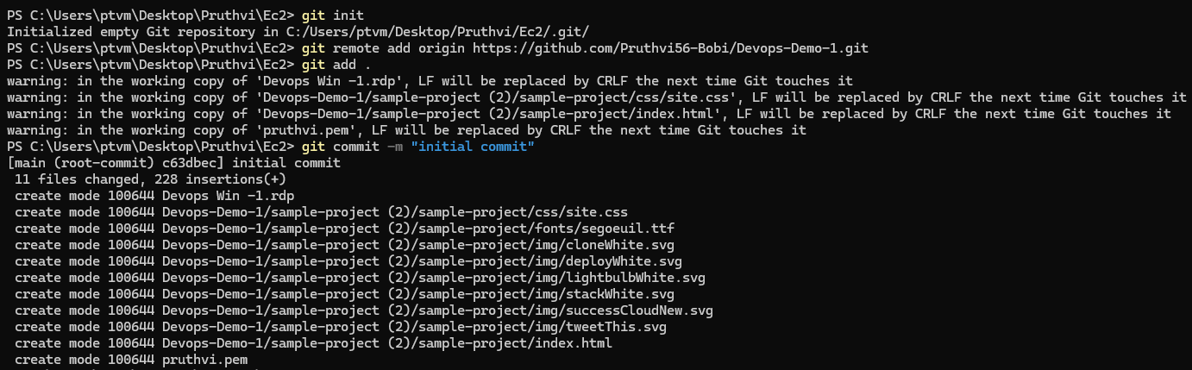

1. Create a new branch for a new feature you want to add to the application

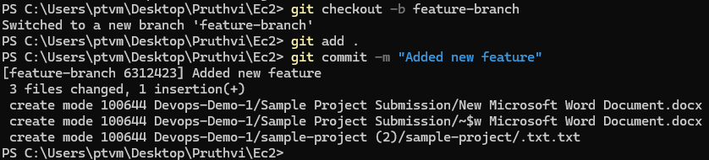

1. Merge back the created branch with the master branch

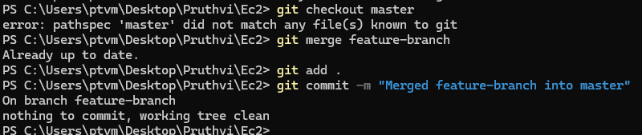

1. Create a remote repository

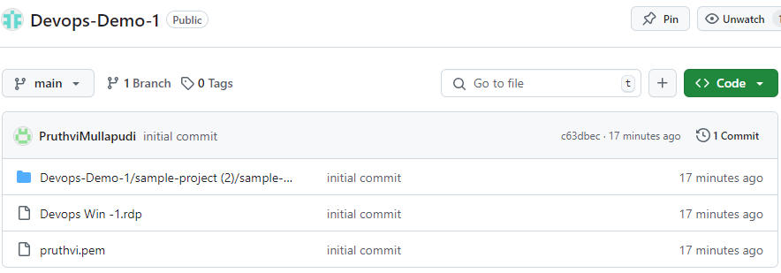

1. Push the local repository to company’s remote repository

